Kubernetes Task -03

Task Title
Kubernetes Workload Deployment, Service Exposure, and Controller Management
Objective
To understand and implement core Kubernetes concepts by:
• Deploying containerized applications (Apache & Nginx)
• Exposing applications internally and externally using Services
• Managing Pod lifecycle using ReplicationController and ReplicaSet
• Performing scaling operations
• Applying label-based selection and filtering
• Validating load balancing behaviour
• Safely deleting controllers without impacting running workloads
Prerequisites
• Working Kubernetes cluster (single-node or multi-node)
• kubectl installed and configured
• Basic knowledge of YAML configuration files
• Container images available (nginx, httpd)
• Network access for NodePort testing
• (If using cloud) Security Group / Firewall rules configured
Conclusion
Through these exercises, the following Kubernetes fundamentals were successfully validated:
• Pods deployed using declarative YAML definitions
• ClusterIP Services enabled internal communication
• NodePort Services enabled external access
• ReplicationController maintained desired Pod replicas
• Scaling operations dynamically adjusted workloads
• ReplicaSets enforced label-based Pod management
• Advanced selectors (multiple labels & exclusions) applied correctly
• NodePort Services distributed traffic across multiple Pods
• Controllers deleted safely while preserving running Pods

- Create a ClusterIP service for an Apache web server pod.
Steps Performed
• Created the Kubernetes configuration file:
vi apache-app.yaml
Pod Definition (Apache Web Server)
• Specified basic Pod configuration:
- apiVersion: v1
- kind: Pod
- metadata:
  - name: apache-pod
  - labels:
    - app: apache
• Configured container:
- name: apache
- image: httpd
- containerPort: 80
Service Definition (ClusterIP)
• Added Service configuration in the same YAML:
- apiVersion: v1
- kind: Service
- metadata:
  - name: apache-clusterip
• Defined Service type:
- type: ClusterIP
• Configured selector:
- app: apache
• Configured ports:
- port: 80
- targetPort: 80
Verified YAML Configuration
• Checked file contents:
cat apache-app.yaml
Applied Kubernetes Configuration
• Executed:
kubectl apply -f apache-app.yaml
Observed:
• Pod created
• Service created
Validated Pod Status
• Checked running Pods:
kubectl get pods
Observed:
• apache-pod → Running
Validated Service Creation
• Checked Services:
kubectl get svc
Observed:
• apache-clusterip → ClusterIP assigned
Verified Service Endpoints
• Executed:
kubectl get endpoints apache-clusterip
Observed:
• Pod IP mapped to port 80
Final Verification
• Confirmed successful Service → Pod communication using label selector:
• app: apache matched between Pod and Service.
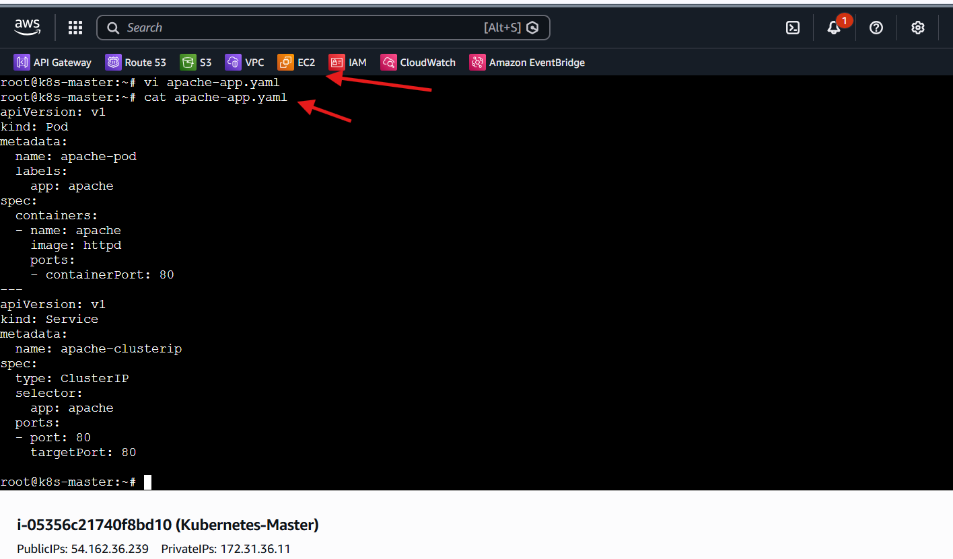
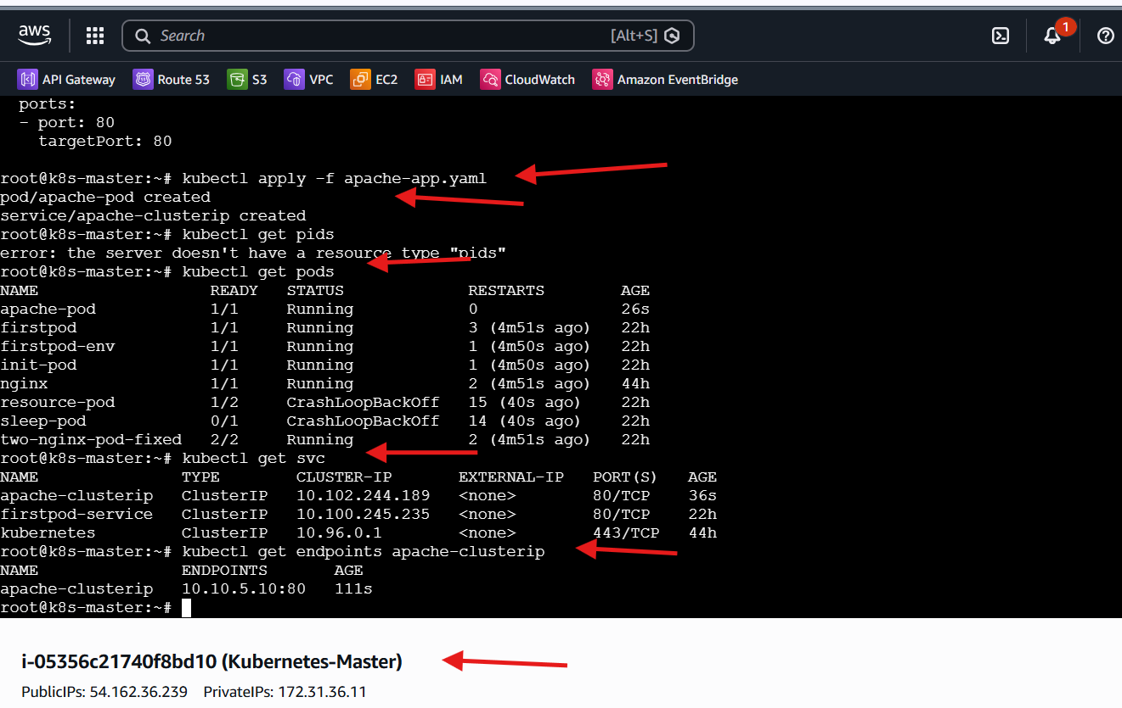

- Expose an Nginx pod externally using a NodePort service.
Steps Performed
• Created the Kubernetes configuration file:
vi nginx-nodeport.yaml
Pod Definition (Nginx)
• Defined an Nginx Pod:
- apiVersion: v1
- kind: Pod
- metadata:
  - name: nginx-pod
  - labels:
    - app: nginx
• Configured container:
- name: nginx
- image: nginx
- containerPort: 80
Service Definition (NodePort)
• Added a NodePort Service:
- apiVersion: v1
- kind: Service
- metadata:
  - name: nginx-nodeport
• Defined Service type:
- type: NodePort
• Configured selector:
- app: nginx
• Configured ports:
- port: 80
- targetPort: 80
- nodePort: 30007
Verified YAML Configuration
• Checked file contents:
cat nginx-nodeport.yaml
Applied Kubernetes Configuration
• Executed:
kubectl apply -f nginx-nodeport.yaml
Observed:
• Pod created
• Service created
Validated Pod Status
• Checked running Pods:
kubectl get pods
Observed:
• nginx-pod → Running
Validated Service Creation
• Checked Services:
kubectl get svc
Observed:
• nginx-nodeport → NodePort assigned (30007)
Verified Pod Placement
• Checked Pod details:
kubectl get pods -o wide
Observed:
• nginx-pod scheduled on worker node
• Pod IP assigned
AWS Security Group Configuration
• Modified EC2 Security Group inbound rules:
- Added Custom TCP rule
- Port range: 30007
- Source: 0.0.0.0/0
Allowed external traffic to NodePort.
Accessed Application Externally
• Retrieved Worker Node Public IP from AWS Console.
• Accessed Nginx in browser:
http://<worker-node-public-ip>:30007
Observed:
• Nginx welcome page displayed successfully
Final Verification
• Confirmed successful external exposure:
• Internet → Node IP → NodePort → Service → Pod
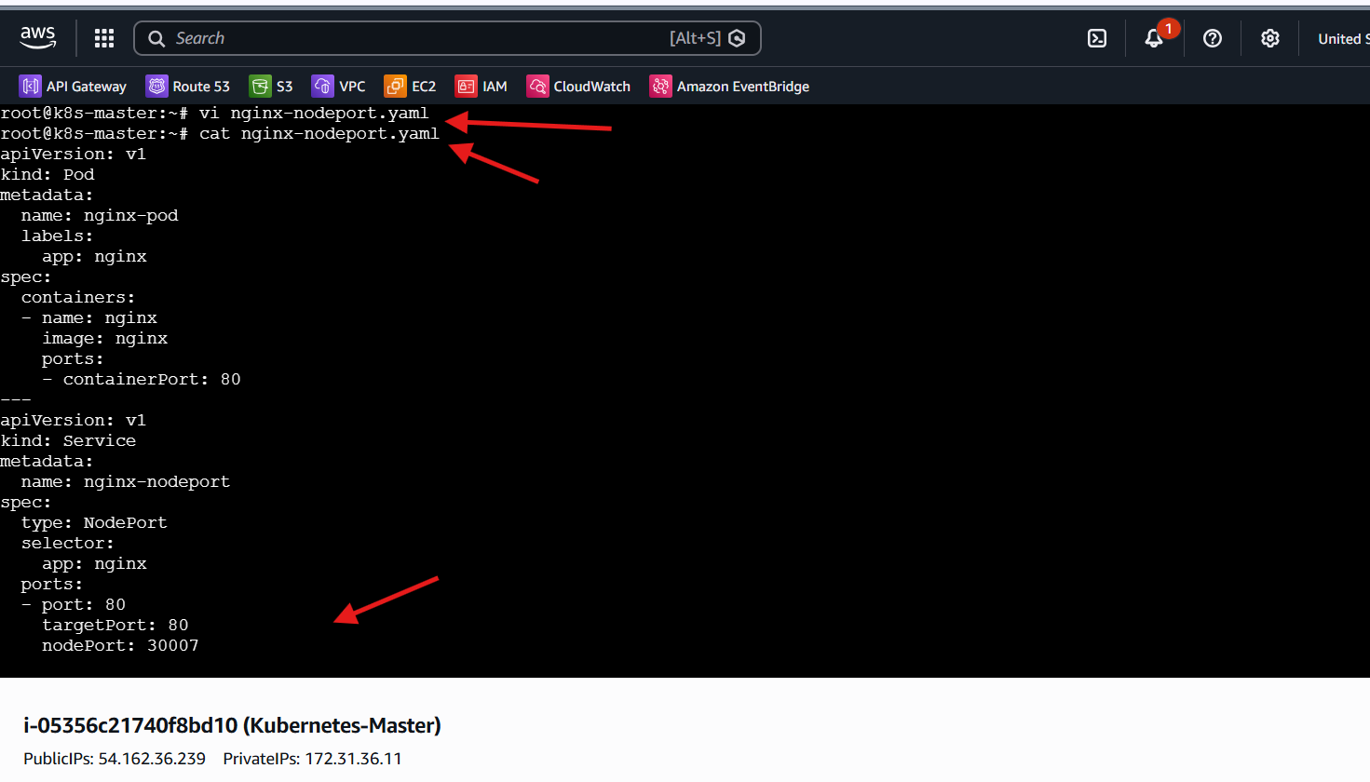
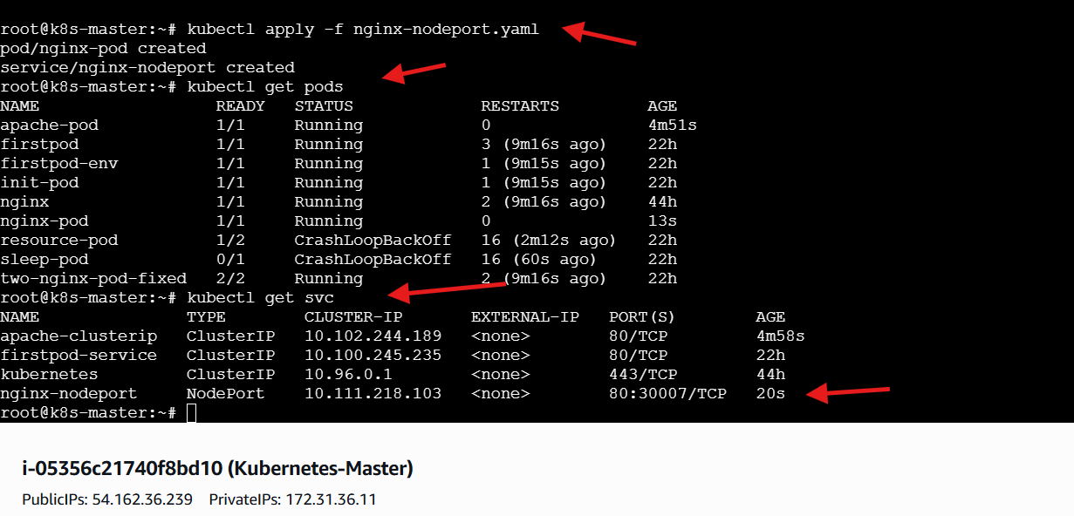
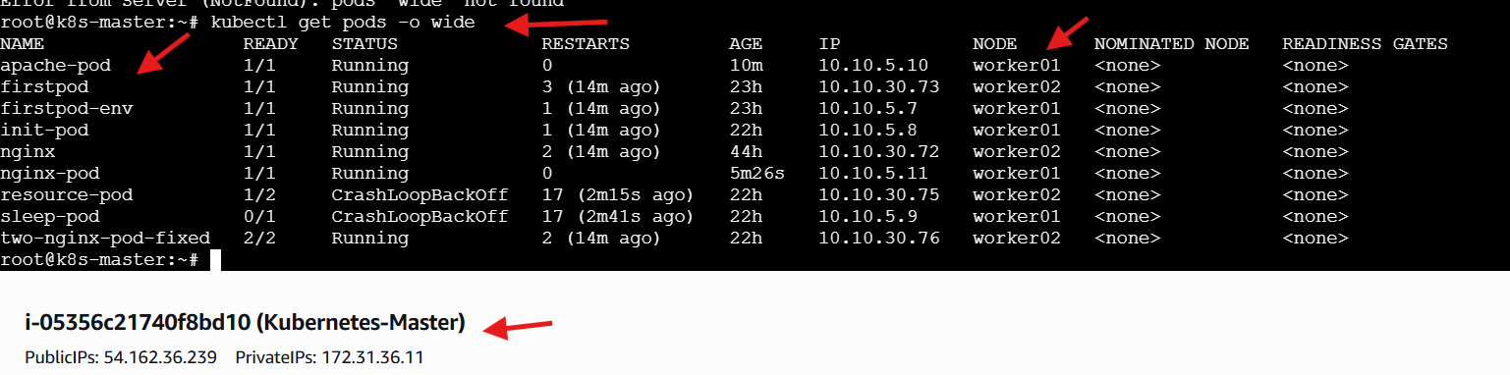
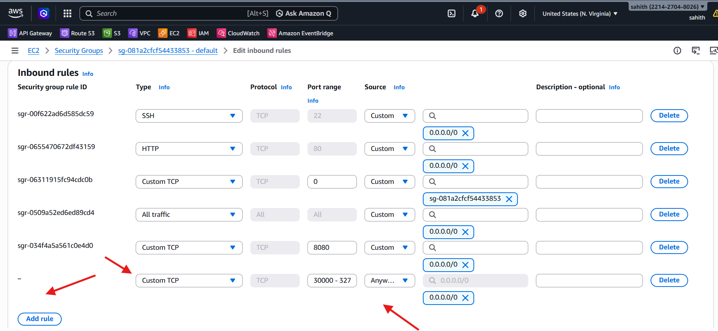
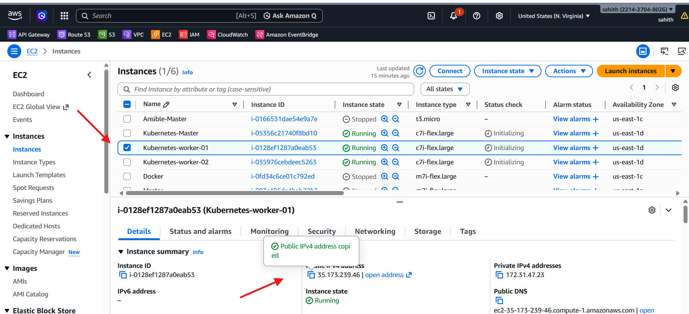
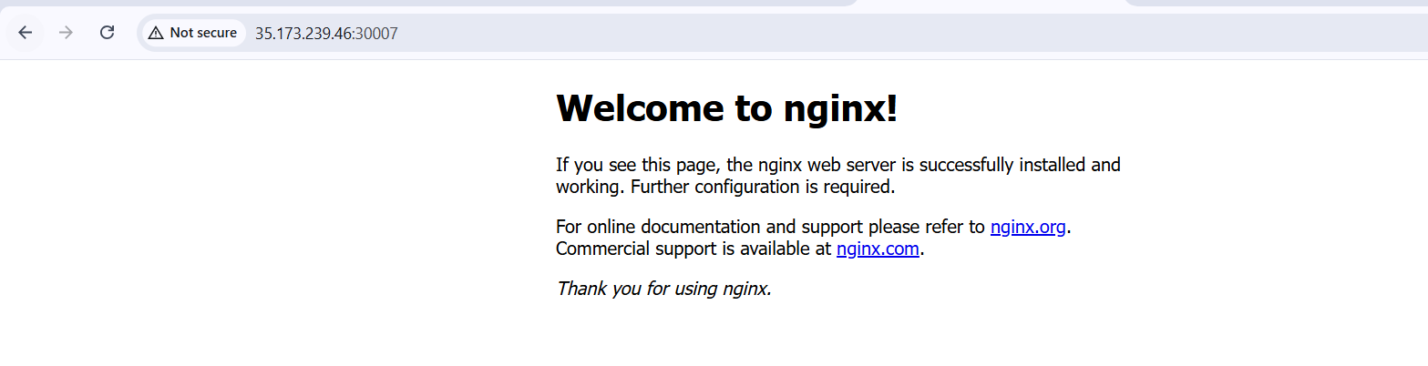

- Deploy a ReplicationController to maintain 3 replicas of an Nginx pod.
Steps Performed
• Created the ReplicationController configuration file:
vi nginx-rc.yaml
ReplicationController Definition
• Specified resource details:
- apiVersion: v1
- kind: ReplicationController
- metadata:
  - name: nginx-rc
Replica Configuration
• Defined desired state:
- replicas: 3
Kubernetes ensures three Pods are always running.
Selector Configuration
• Configured label selector:
- app: nginx-rc
Used to identify Pods managed by the controller.
Pod Template Definition
• Defined Pod template inside RC:
- metadata:
  - labels:
    - app: nginx-rc
• Configured container:
- name: nginx
- image: nginx
- containerPort: 80

Verified YAML Configuration
• Checked file contents:
cat nginx-rc.yaml

Applied Replication Controller
• Executed:
kubectl apply -f nginx-rc.yaml
Observed:
• ReplicationController created
Validated Pod Creation
• Checked Pods:
kubectl get pods
Observed:
• Three Pods created automatically
• Pod names generated with suffixes:
- nginx-rc-xxxxx
Final Verification
• Confirmed replication behaviour:
• Desired replicas: 3
• Running Pods: 3
Replication Controller successfully maintaining Pod availability.
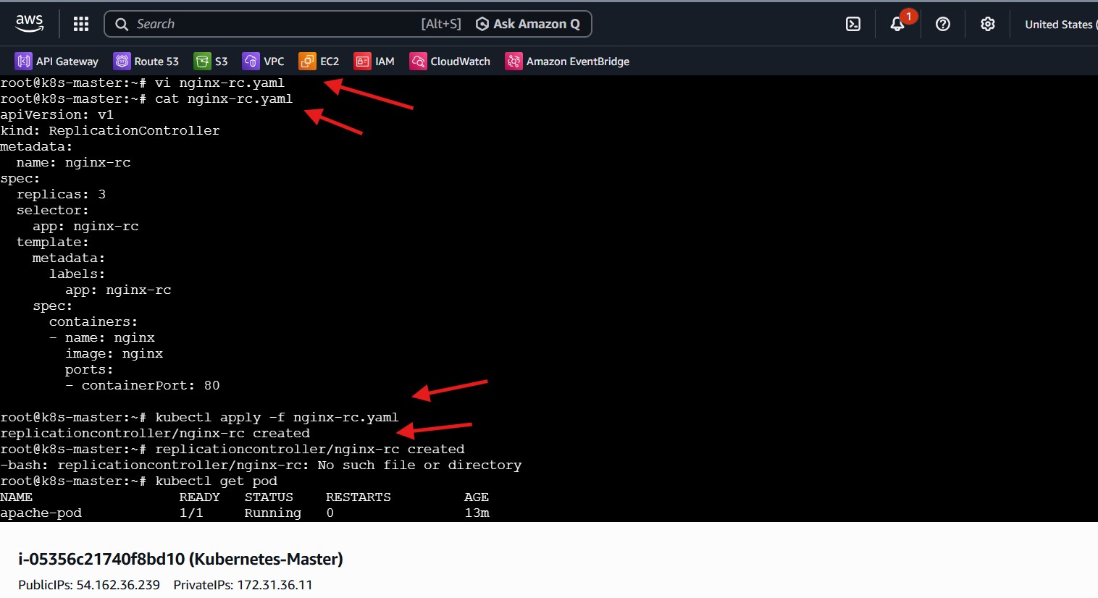
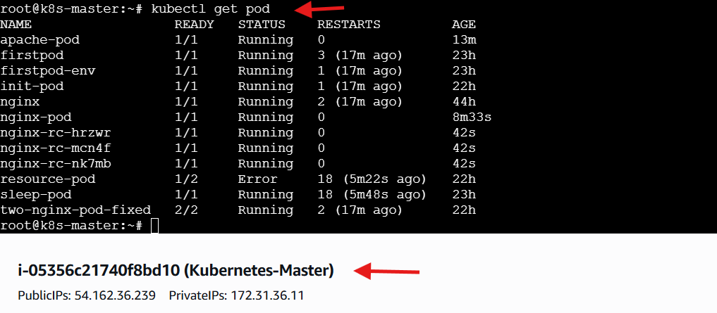

- Scale the ReplicationController from 3 replicas to 5 replicas.
Steps Performed
• Verified the existing ReplicationController state.
• Executed the scaling command:
kubectl scale rc nginx-rc --replicas=5
Observed:
• ReplicationController scaled successfully
Validated Pod Scaling
• Checked Pods after scaling:
kubectl get pods
Observed:
• Additional Pods created automatically
• Total running Pods increased from 3 → 5
• Newly created Pods received generated names:
- nginx-rc-xxxxx
Final Verification
• Desired replicas: 5
• Running Pods: 5
ReplicationController successfully scaled and maintaining updated replica count.
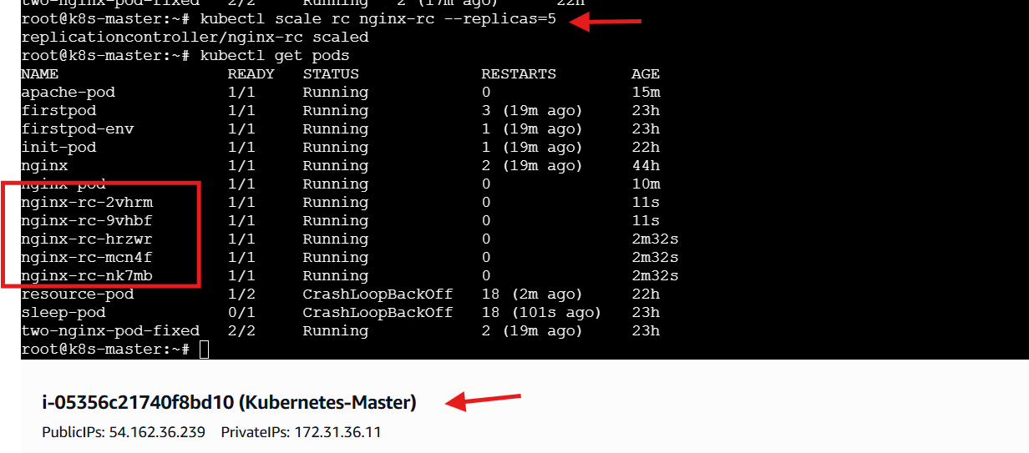

- Create a ReplicaSet to manage pods based on multiple labels (prod and test).
Steps Performed
• Created the ReplicaSet configuration file:
vi multi-label-rs.yaml
ReplicaSet Definition
• Specified resource details:
- apiVersion: apps/v1
- kind: ReplicaSet
- metadata:
  - name: multi-label-rs
Replica Configuration
• Defined desired replicas:
- replicas: 3
ReplicaSet maintains three Pods.

Multiple Label Selector Configuration
• Configured selector using multiple labels:
- matchLabels:
  - app: nginx
  - environment: prod
Pods must match both labels to be managed.
Pod Template Definition
• Defined Pod labels:
- app: nginx
- environment: prod
• Configured container:
- name: nginx
- image: nginx
Verified YAML Configuration
• Checked file contents:
cat multi-label-rs.yaml
Applied ReplicaSet Configuration
• Executed:
kubectl apply -f multi-label-rs.yaml
Observed:
• ReplicaSet created successfully
Validated ReplicaSet Status
• Checked ReplicaSet:
kubectl get rs
Observed:
• Desired: 3
• Current: 3
• Ready: 3
Validated Pod Creation
• Checked Pods:
kubectl get pods
Observed:
• Pods created with generated names:
- multi-label-rs-xxxxx
• Pods matched multiple labels:
- app: nginx
- environment: prod
Final Verification
• Confirmed ReplicaSet managing Pods based on multiple label matching condition
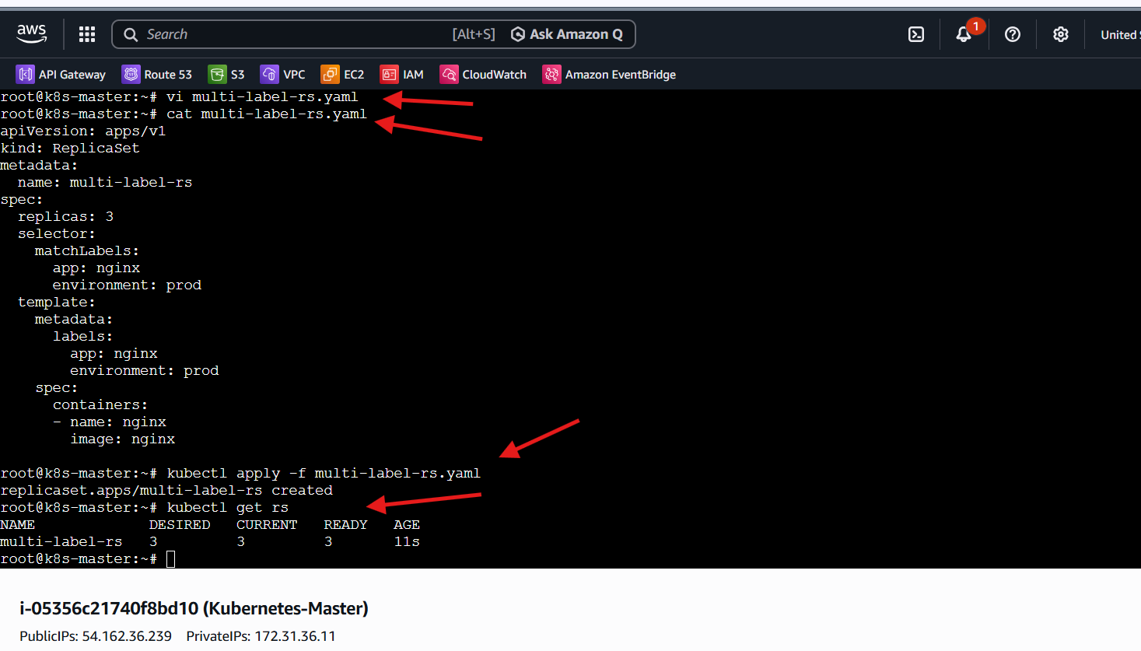
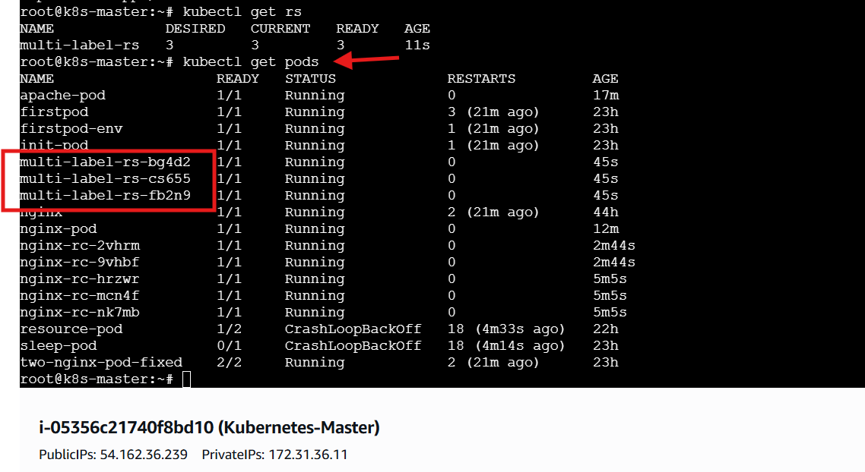

- Deploy a ReplicaSet that excludes pods with the label backend.
Steps Performed
• Created the ReplicaSet configuration file:
vi exclude-backend-rs.yaml
ReplicaSet Definition
• Specified resource details:
- apiVersion: apps/v1
- kind: ReplicaSet
- metadata:
  - name: exclude-backend-rs
Replica Configuration
• Defined desired replicas:
- replicas: 3
ReplicaSet maintains three Pods.
Selector Configuration (Excluding Backend Pods)
• Used matchExpressions for label-based filtering:
- key: tier
- operator: NotIn
- values:
  - backend
ReplicaSet will manage Pods whose tier label is NOT backend.
Pod Template Definition
• Assigned Pod label:
- tier: frontend
Ensures Pods satisfy exclusion rule.
• Configured container:
- name: nginx
- image: nginx
Verified YAML Configuration
• Checked file contents:
cat exclude-backend-rs.yaml
Applied ReplicaSet Configuration
• Executed:
kubectl apply -f exclude-backend-rs.yaml
Observed:
• ReplicaSet created successfully
Validated ReplicaSet Status
• Checked ReplicaSet:
kubectl get rs
Observed:
• Desired: 3
• Current: 3
• Ready: 3
Validated Pod Labels
• Verified labels:
kubectl get pods --show-labels
Observed:
• ReplicaSet Pods labeled:
- tier=frontend
No Pods with tier=backend selected
Final Verification
• Confirmed ReplicaSet correctly applying label exclusion logic (NotIn operator)
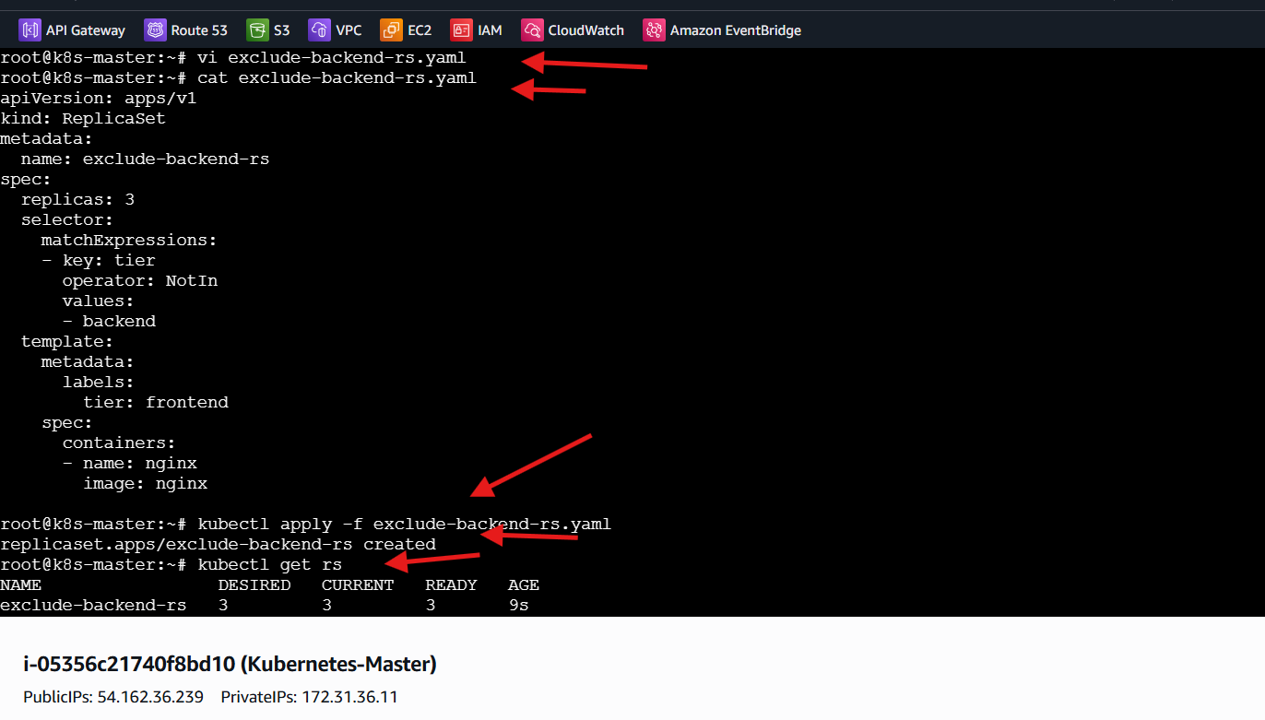
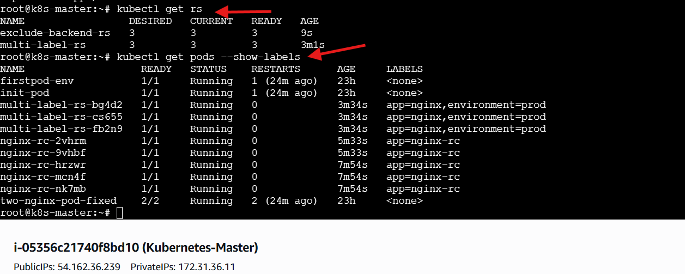

- Test load balancing across multiple pods using a NodePort service.
Steps Performed
• Created the Deployment and Service configuration file:
vi lb-nginx.yaml
Deployment Definition
• Defined an Nginx Deployment:
- apiVersion: apps/v1
- kind: Deployment
- metadata:
  - name: nginx-deploy
Replica Configuration
• Specified desired replicas:
- replicas: 3
Ensures multiple Pods for load balancing.
Selector Configuration
• Configured label selector:
- matchLabels:
  - app: lb-nginx
Pod Template Definition
• Assigned Pod labels:
- app: lb-nginx
• Configured container:
- name: nginx
- image: nginx
- containerPort: 80
Service Definition (NodePort)
• Added NodePort Service:
- apiVersion: v1
- kind: Service
- metadata:
  - name: lb-service
• Defined Service type:
- type: NodePort
• Configured selector:
- app: lb-nginx
• Configured ports:
- port: 80
- target Port: 80
- node Port: 30008
Verified YAML Configuration
• Checked file contents:
cat lb-nginx.yaml
Applied Deployment & Service
• Executed:
kubectl apply -f lb-nginx. yaml
Observed:
• Deployment created
• Service created
Validated Deployment Status
• Checked Deployment:
kubectl get deploy
Observed:
• Desired replicas: 3
• Available replicas: 3
Validated Pod Distribution
• Checked Pods:
kubectl get pods -o wide
Observed:
• Multiple Pods running
• Pods scheduled across worker nodes
Enables real load balancing.
Validated Service Exposure
• Checked Services:
kubectl get svc
Observed:
• lb-service → NodePort 30008 assigned
Tested Load Balancing
• Retrieved Worker Node Public IP.
• Accessed application:
http://<worker-node-public-ip>:30008
Observed:
• Nginx welcome page displayed
• Repeated browser refresh requests:
Traffic distributed across multiple Pods
Final Verification
• Confirmed successful load balancing behavior:
• Client → Node IP → NodePort → Service → Multiple Pods
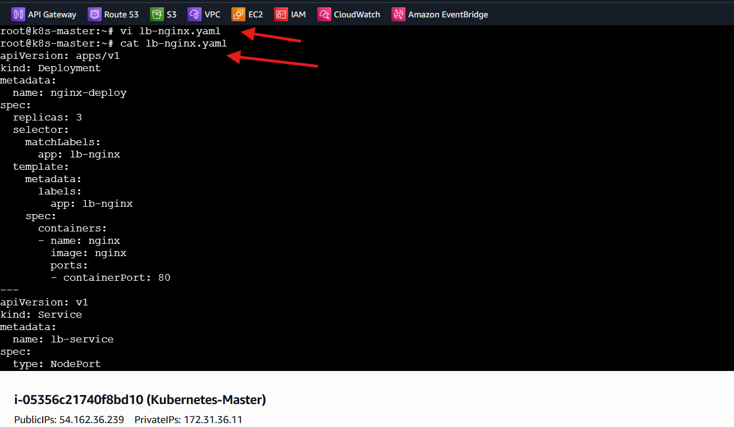
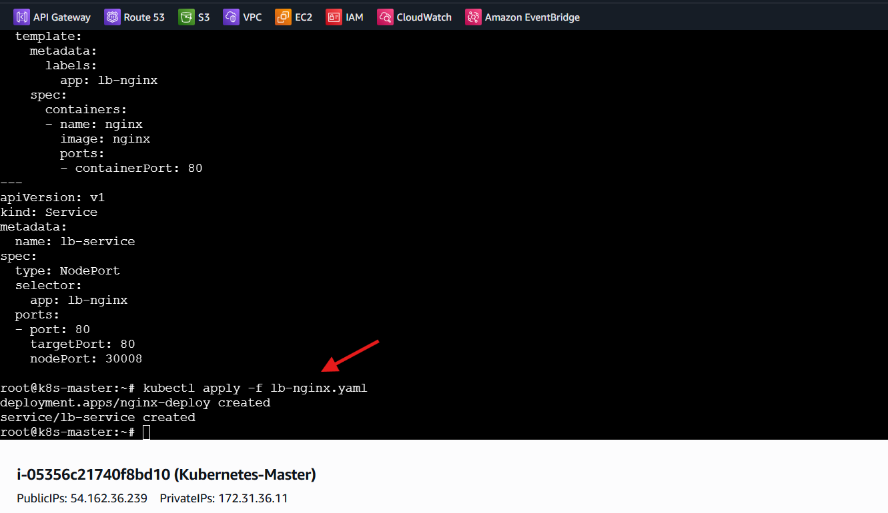
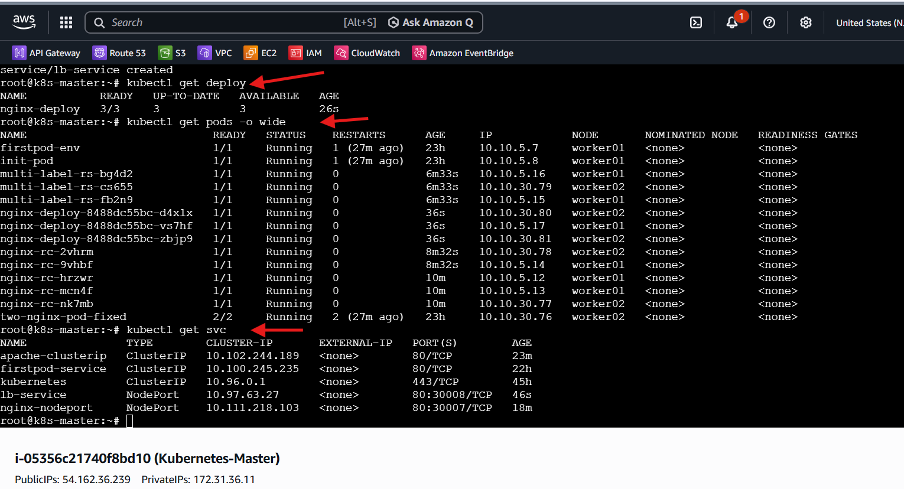
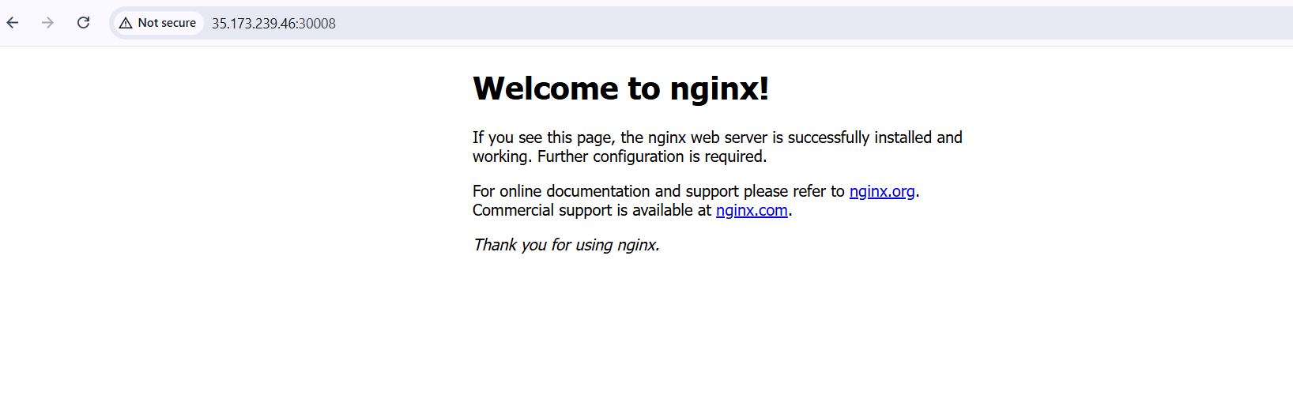
- Delete a ReplicationController without affecting the running pods.

Steps Performed
• Executed the deletion command with orphan option:
kubectl delete rc nginx-rc --cascade=orphan
Observed:
• ReplicationController deleted successfully
Validated Pod Status After Deletion
• Checked running Pods:
kubectl get pods
Observed:
• Pods previously managed by the ReplicationController still running
No Pods terminated.
Behaviour Verification
• --cascade=orphan flag used:
Deletes only the ReplicationController
Leaves Pods untouched
Final Verification
• ReplicationController → Deleted
• Pods → Still Running
Successfully removed controller without impacting workloads.
